# Summary Paper Outline v0.1

# Title: Scenario Development Techniques: Updated Review and Guidance

# Journal: Futures/Technological Forecasting and Social Change

1. **Introduction**

* Scenario planning and development techniques have gained new impetus as an important tool to tackle the many challenging and complex issues facing society today.
* There are many techniques and methods available to analysts today to conduct scenario planning and development.
* While some techniques such as the Delphi Method have been used for many decades, there has been numerous new techniques introduced in recent years that aims to add additional quantitative rigor in the field.
* However, the sheer number of different techniques available in the field can sometimes overwhelm analysts, and analysts often choose a technique due to convenience rather than fit.
* While there have been several systematic literature reviews (Bishop et al., Borjeson et al., Van Notten et al., Amer et al., Varum and Melo., and Addo-Tenkorang), most of them have been over ten years old, and focused mostly on the qualitative techniques instead of some of the new quantitative techniques that are introduced.
* Furthermore, while some of them offered a high-level organization/categorization of the techniques, none of the existing review offered a useful guide for analysts to compare the strengths and weaknesses of each technique, nor provided a tool for analysts to select the most appropriate technique for their problem at hand.
* This paper will attempt to address these gaps in the field by:
  + Provide a literature update of the set of techniques used by analysts in scenario planning today, with focus on the quantitative methods introduced into the field within the past ten years.
  + Provide a framework for analysts to understand the strengths and weaknesses of some of the popular techniques, and a roadmap to assist analysts of when a technique is appropriate to be used.

1. **Literature Review/Techniques**

* To help analysts assess the strengths and weaknesses of the set of techniques and appropriately select the most appropriate one, there needs to be a set of distinguishing features to evaluate the techniques against.
* There have been prior efforts by other researchers to create a topology to categorize, even just at a high-level, the set of techniques that are available to analysts. These included:
  + Van Notten et al. who studied 70 scenario planning case studies and categorized them based on the themes of project goal (why?), process design (how?), and scenario content (why?).
  + Borjeson et al. classified techniques based on the question they tried to answer:
    - Predictive: what will happen?
    - Explorative: what can happen?
    - Normative: given a goal, how to get there?
  + Bishop et al. extended the work of Van Notten et al. and Borjeson et al. by extending their classification to eight categories, based on the technique’s process, output, and organization.
* While these all provided a high-level categorization of scenario planning techniques, they primarily focused on the more qualitative methods available at the time.
* Furthermore, none of them provided a roadmap for analysts to understand the relative strengths and weaknesses of the techniques reviewed, nor did they assist analysts understand when a certain technique should be used.
* This paper aims to extend the high-level organization structure introduced by Borjeson et al. and Bishop et al., but with greater levels of detail in the framework.
* This framework will include three design principles:
  + Perpetual orthogonality: Ensure each method will only appear in a leaf category once.
  + Completeness: The category provides as close as possible a complete set of features for scenario planning techniques.
  + Parallel structure: Each level of the category provides similar resolution.
  1. **Methods**
* To ensure the categories are well-thought out and rigorous, a set of taxonomy/method categorization literature that extended beyond the field of future studies were studied. These included:
  + Baladi et al. (Virtual Environment)
  + Utting et al. (Software testing model taxonomy)
  + Ostergaard and Summers (Collaborative design taxonomy)
  + Ceret et al. (Robust system design)
  + Roise et al. (Design competency)
  + Provide a quick summary of each of the taxonomy.
  1. **Proposed Categorization**
* Go through each of the major headings (themes)
  + Question: What is the method trying to answer?
  + Data: What kind of data does the method use?
  + Output: What type of output does the method produce?
  + Tools: What additional tools/analysis does the method use/considers?
  + Organization: How do analysts use the method to perform their analysis?
    1. Questions
* Adopted from Borjeson et al.
* Three categories of questions: Normative, Predictive, Explorative.
  + An example of each one here would be useful.
  + Compare and contrast between them.
  + Provide examples of methods that are in each category.
    1. Data:
* Categorizes the techniques based on the type of data it utilizes:
  + Expert input?
  + Qualitative input?
  + Probabilistic versus descriptive?
  + Are data organized in well-defined modules?
  + Does it include real-time data?
* Provide an example method for each sub-heading.
  + 1. Output
* Categorizes the techniques based on the output it provides for the analysts:
  + Does it have a long event horizon or short event horizon (is it suited for long-term planning?
  + Does the technique generate a narrative or does it provide a quantitative scenario output?
  + Does the technique generate more than one potential outcome?
* Add examples for each?
  + 1. Tools
* What common tools and methods does the technique incorporate?
* These include:
  + Sensitivity analysis?
  + Uncertainty analysis?
  + Detailed system modeling?
    1. Organization
* How do the analysts use the technique? What organizational structure is required for the technique to be implemented?
  + Is the technique cyclical or linear?
  + Do they require high levels of collaboration or do analysts work in isolation?
  + Is the technique iterative?
  + Does it require a structured leader to lead the analysts, or is authority more distributed amongst the participants?
  + Are the participants for the technique physically located in the same location or can they work in distributed locations?
  + Do the participants work in synchronous with each other, or can they participant in an asynchronous manner?

1. **Results**

* Present the final matrix of the different methods appropriately categorized.
* Present the result on a method-by-method manner (going across through the columns).
  + Frame this result as strengths and weaknesses of each method.
  + For example:
    - The Delphi method of expert elicitation is best suited when the analyst is attempting to understand how to reach a certain goal in the long-term future. It uses expert input from numerous experts, but they are mostly descriptive and often are qualitative in nature. This method is quick to implement, but does not include sensitivity analysis, uncertainty analysis, nor system modeling.
* Compare-and-contrast between the methods, pay special attention to similarities and cluster them together.
* Go through the extensibility of the framework.
  + Can quickly evaluate new methods as they appear.
  + New attributes can also be added.
* To assist analysts to choose the appropriate method, a decision tree of the categories is created.
* One incomplete sample tree is:

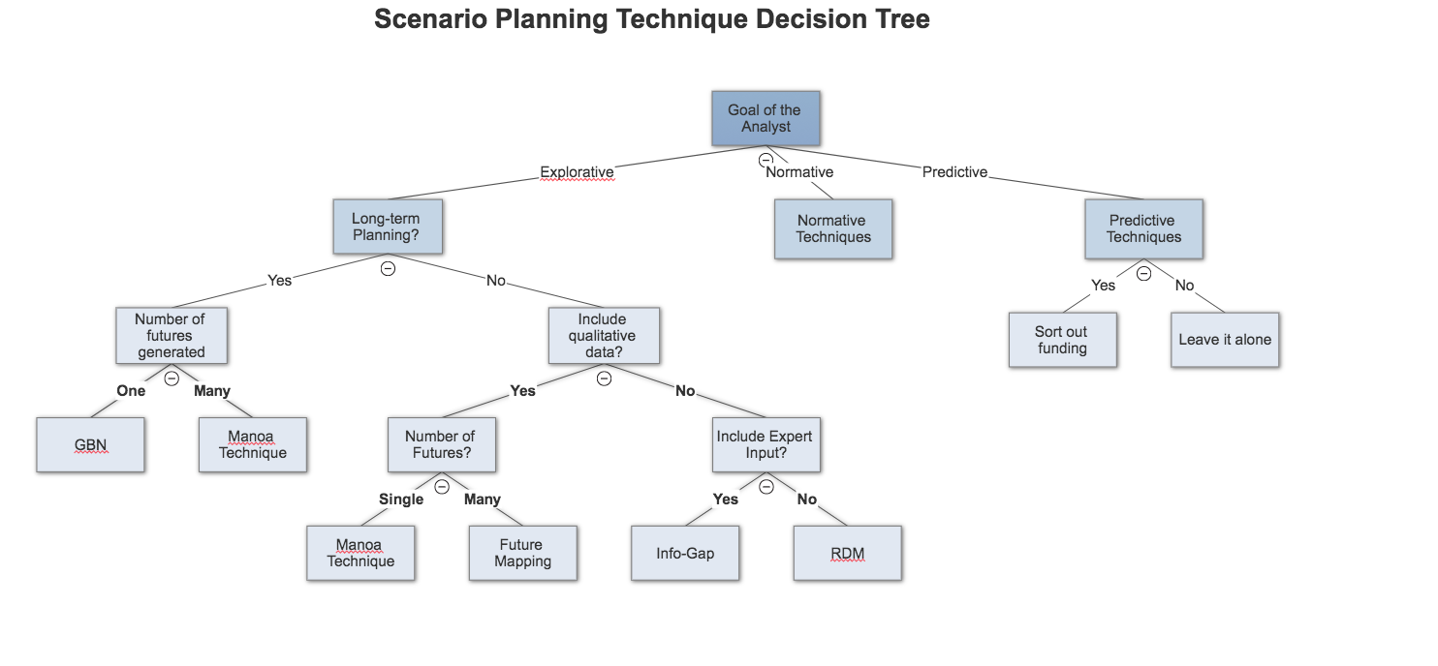

1. **Discussion:**

* The paper aims to address the gap in the current literature in both the evaluation of new scenario planning techniques, and the lack of guidance for analysts to choose an appropriate technique for their problem.
* There are many times where analysts choose a specific technique simply due to familiarity rather than appropriateness.
  + Use examples from Ringeland (1998).
* By asking a few selected questions, an analyst can find an appropriate method for the problem they intend to solve.
* However, there are several limitations to this review:
  + The techniques surveyed is not an exhaustive list, and completeness was never a goal. While methods were selected for their general representativeness, there are definite gaps in set of techniques. The framework’s extensibility however will allow new methods to be added.
  + While most of the categories are worded in binary terms (yes/no), there are times where a technique will fall in between the two. For example, a technique can be mostly for long-term planning, but can also be used for near-term planning as well. That distinction was missing from this analysis.
* Finally, this research also showed a need for a collaborative, expert-based concurrent design process that incorporates sensitivity analysis and uncertainty analysis such as CADS. NEED TO EXPAND MORE.